Pinhole penguin

A bright lamp that is the shape of a penguin is turned on.
It is put in front of a tiny cross-shaped hole.

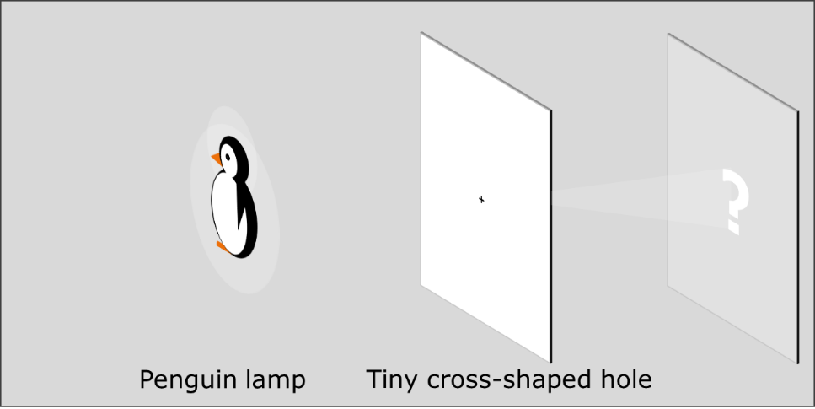

a. What would you expect to see on the screen?
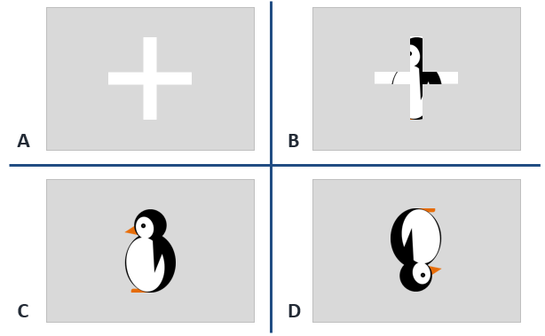

Rays of light show which way light moves from the penguin lamp.
b. What can you say about rays to explain what you see on the screen?
For each statement, tick (✓) one column to show what you think.
 |  | I am sure this is right | I think this is right | I think this is wrong | I am sure this is wrong
A | Rays from the corners of the penguin are blocked
B | One ray from each point of the penguin goes through the cross
C | Many rays from each point of the penguin go through the cross
D | Light moving along each ray lights up a point on the screen
E | Light moving along rays from one point of the penguin go through the hole at a particular angle

Physics > Big idea PSL: Sound, light and waves > Topic PSL3: Making images > Key concept PSL3.1: The ray model of light to explain images
Diagnostic question
Pinhole penguin

Overview
Learning focus: | Only some light rays from each point of an illuminated object can pass through a pinhole, hitting a screen at distinct points to make an inverted image.
Observable learning outcome: | Explain how an image is formed on a screen behind a pinhole.
Question type: | Two-tier multiple choice with a confidence grid
Key words: | Light ray, pinhole, image

What does the research say?
In order to explain image formation students need to understand that a light is emitted in all directions from each point on the source (Rice and Feher, 1987; Dedes and Kanstantinos, 2007; Galili and Hazan, 2000; Andreou and Raftopoulos, 2011). A suitable conceptual progression of how an image in a pinhole camera forms might start with the idea that rays represent the direction light travels in; use rays to show light moving from a luminous or illuminated object towards a pinhole; and finish with a few rays from each point, out of infinitely many, passing through the pinhole and contributing to the formation of an image (Andreou and Raftopoulos, 2011).
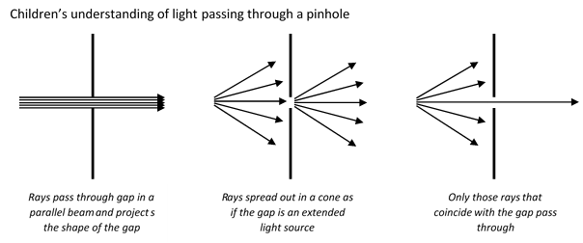
Without the correct understanding of light emission from extended sources students make mistakes explaining how light passes through a pinhole. Galili and Hazan (2000) found over a third of students aged 14-16 thought light passed through a pinhole in a parallel beam. A further third thought that light spread out after the pinhole as if the hole was an extended source of light, and after instruction this increased to more than half.
Students often think of an image as a physical replication of an object which can travel, remain still or turn as a whole. They may ascribe active powers to mirrors, lenses or pinholes to manipulate images in order to explain how they appear in a particular way on a screen (Galili and Hazan, 2000). In describing how light passes through a pinhole to form an image Rice and Feher (1987) found up to 20% of 9- to 13-year-olds ascribe such active power to the hole.
Ways to use this question
Students should complete the questions individually. This could be a pencil and paper exercise, or you could use an electronic ‘voting system’ or mini white boards and the PowerPoint presentation. The follow on question will give you insights into how they are thinking and highlight specific misconceptions that some may hold.
If there is a range of answers, you may choose to respond through structured class discussion. Ask one student to explain why they gave the answer they did; ask another student to explain why they agree with them; ask another to explain why they disagree, and so on. This sort of discussion gives students the opportunity to explore their thinking and for you to really understand their learning needs.
Differentiation
You may choose to read the questions to the class, so that everyone can focus on the science. In some situations it may be more appropriate for a teaching assistant to read for one or two students.

Expected answers
a. Answer D

b. Answers C, D and E are correct.
From each point of the penguin many rays of light pass through the tiny cross. They all pass through at approximately the same angle and the light moving along each ray creates a point of colour on the screen.
Light along a ray from the top left of the penguin passes through the hole and hits the bottom right of the screen, and in this way the image on the screen is inverted.
How to respond - what next?
a. Rice and Feher (1987) found that about 50% of 9- to 13-year-olds predicted the image of an object through a tiny hole is the shape of the hole (answers A and B) with a further 17% blending the shape of the object and the hole (answer B). 33% of these students predicted the image would be the shape of the object. (This survey does not differentiate between answers C and D because a symmetrical object was used.)
b. Answer A suggests students are persisting in thinking of light moving in a parallel beam towards the screen. The diagnostic question: Light direction investigates how students think about the direction light moves in.
Answer B suggests students are persisting in thinking that one ray of light is emitted from each point on an extended source. The diagnostic question: Light bulb moment investigates how students think about light rays emanating from each point of an illuminated object.
If students have misunderstandings about how an image is formed on a screen behind a pinhole, it can help to draw real time ray diagrams with the class, in order to scaffold how rays of light pass through a tiny hole to form an image. That is, to have the class draw ray diagrams at the same time as the teacher, working step by step through the construction whilst simultaneously asking questions and explaining each step.
This scaffolding approach can lead to challenging students to predict and explain the images formed when there is more than one pinhole, or if the pinhole is enlarged. These situations require students to apply the scientific understanding of image formation to novel situations, which helps consolidate individual understanding. The following BEST ‘response activity’ is a resource that can be used to do this:
- Response activity: Pinhole camera
Acknowledgments
Developed by Peter Fairhurst (UYSEG).
Images: Peter Fairhurst (UYSEG).
References
Andreou, C. and Raftopoulos, A. (2011). Lessons from the history of the concept of the ray for teaching geometric optics. Science and Education, 20, 1007-1037.
Dedes, C. and Kanstantinos, R. (2007). Teaching image formation by extended light sources: the use of a model derived from the history of science. Research in Science Education, 39, 57-73.
Galili, I. and Hazan, A. (2000). Learners' knowledge in optics: interpretation, structure and analysis. International Journal of Science Education, 22(1), 57-88.
Rice, K. and Feher, E. (1987). Pinholes and images: childres's conceptions of light and vision. Science Education, 71(4), 629-639.

